 ΠΑΓΚΟΣΜΙΑ ΡΕΚΟΡ ΚΟΛΥΜΒΗΣΗΣ (ΠΙΣΙΝΑ 25μ.)
ΑΝΔΡΕΣ
ΑΓΩΝΙΣΜΑ | ΑΘΛΗΤΗΣ | ΧΩΡΑ | ΗΜ/ΝΙΑ | ΕΠΙΔΟΣΗ | ΒΑΘΜΟΛΟΓΙΑ FINA
50 Ελεύθερο | CROOKS JORDAN | CAYMAN ISLANDS | 14/12/24 | 19.90 | 1000
100 Ελεύθερο | CHALMERS KYLE | AUSTRALIA | 29/10/21 | 44.84 | 1000
200 Ελεύθερο | HOBSON LUKE | UNITED STATES | 15/12/24 | 1:38.61 | 1000
400 Ελεύθερο | AGNEL YANNICK | FRANCE | 15/11/12 | 3:32.25 | 1000
800 Ελεύθερο | WIFFEN DANIEL | IRELAND | 10/12/23 | 7:20.46 | 1000
1500 Ελεύθερο | WELLBROCK FLORIAN | GERMANY | 21/12/21 | 14:06.88 | 1000
50 Ύπτιο | KOLESNIKOV KLIMENT | RUSSIA | 23/11/22 | 22.11 | 1000
100 Ύπτιο | STEWART COLEMAN | UNITED STATES | 30/8/21 | 48.33 | 1000
200 Ύπτιο | KOS HUBERT | HUNGARY | 24/10/25 | 1:45.12 | 1014
50 Πεταλούδα | PONTI NOE | SWITZERLAND | 11/12/24 | 21.32 | 1000
100 Πεταλούδα | LIENDO JOSH | CANADA | 24/10/25 | 47.68 | 1001
200 Πεταλούδα | HONDA TOMORU | JAPAN | 22/10/22 | 1:46.85 | 1000
50 Πρόσθιο | SAKCI EMRE | TURKEY | 28/12/21 | 24.95 | 1000
100 Πρόσθιο | SHYMANOVICH ILYA | BELARUS | 26/11/21 | 55.28 | 1000
200 Πρόσθιο | PRIGODA KIRILL | RUSSIA | 13/12/18 | 2:00.16 | 1000
100 Μ.Α. | DRESSEL CAELEB | UNITED STATES | 22/11/20 | 49.28 | 1000
200 Μ.Α. | MARCHAND LEON | FRANCE | 1/11/24 | 1:48.88 | 1000
400 Μ.Α. | SETO DAIYA | JAPAN | 20/12/19 | 3:54.81 | 1000
4Χ50 Ελεύθερο | DRESSEL C, HELD R, CONGER J,CHADWICK M | UNITED STATES | 14/12/18 | 1:21.80 | 1000
4Χ100 Ελεύθερο | ALEXY J, HOBSON L, SMITH K, GUILIANO C | UNITED STATES | 10/12/24 | 3:01.66 | 1000
4Χ200 Ελεύθερο | HOBSON L, FOSTER C, CASAS S, SMITH K | UNITED STATES | 13/12/24 | 6:40.51 | 1000
4Χ50 Μ.Ο. | MORA L, MARTINENGHI N, RIVOLTA M, DEPLANO L | ITALY | 17/12/22 | 1:29.72 | 1000
4Χ100 Μ.Ο. | LIFINTSEV M, PRIGODA K, MINAKOV A, KORNEV E | RUSSIA | 15/12/24 | 3:18.68 | 1000
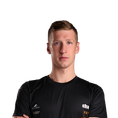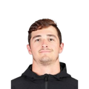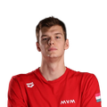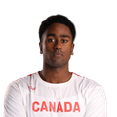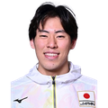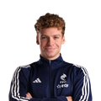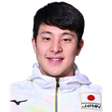
ΓΥΝΑΙΚΕΣ
ΑΓΩΝΙΣΜΑ | ΑΘΛΗΤΡΙΑ | ΧΩΡΑ | ΗΜ/ΝΙΑ | ΕΠΙΔΟΣΗ | ΒΑΘΜΟΛΟΓΙΑ FINA
50 Ελεύθερο | WALSH GRETCHEN | UNITED STATES | 15/12/24 | 22.83 | 1000
100 Ελεύθερο | DOUGLASS KATE | UNITED STATES | 19/10/25 | 50.19 | 1003
200 Ελεύθερο | O’CALLAGHAN MOLLIE | AUSTRALIA | 20/10/25 | 1:49.77 | 1014
400 Ελεύθερο | MC INTOSH SUMMER | CANADA | 10/12/24 | 3:50.25 | 1000
800 Ελεύθερο | LEDECKY KATIE | UNITED STATES | 5/11/22 | 7:57.42 | 1000
1500 Ελεύθερο | LEDECKY KATIE | UNITED STATES | 30/10/22 | 15:08.24 | 1000
50 Ύπτιο | SMITH REGAN | UNITED STATES | 13/12/24 | 25.23 | 1000
100 Ύπτιο | SMITH REGAN | UNITED STATES | 15/12/24 | 54.02 | 1000
200 Ύπτιο | MCKEOWN KAYLEE | AUSTRALIA | 20/10/25 | 1:57.87 | 1004
50 Πεταλούδα | WALSH GRETCHEN | UNITED STATES | 12/10/25 | 23.72 | 1028
100 Πεταλούδα | WALSH GRETCHEN | UNITED STATES | 14/12/24 | 52.71 | 1000
200 Πεταλούδα | MC INTOSH SUMMER | CANADA | 12/12/24 | 1:59.32 | 1000
50 Πρόσθιο | MEILUTYTE RUTA | LITHUANIA | 17/12/22 | 28.37 | 1000
100 Πρόσθιο | MEILUTYTE RUTA | LITHUANIA | 12/10/13 | 1:02.36 | 1000
 | & ATKINSON ALIA | JAMAICA | 26/8/16 | 1:02.36 | 1000
200 Πρόσθιο | DOUGLASS KATE | UNITED STATES | 13/12/24 | 2:12.50 | 1000
100 Μ.Α. | WALSH GRETCHEN | UNITED STATES | 13/12/24 | 55.11 | 1000
200 Μ.Α. | DOUGLASS KATE | UNITED STATES | 10/12/24 | 2:01.63 | 1000
400 Μ.Α. | MC INTOSH SUMMER | CANADA | 14/12/24 | 4:15.48 | 1000
4Χ50 Ελεύθερο | KROMOWIDJOJO R, DE WAARD M, BUSCH K, HEEMSKERK F | NETHERLANDS | 12/12/20 | 1:32.50 | 1000
4Χ100 Ελεύθερο | DOUGLASS K, BERKOFF K, SHACKELL A, WALSH G | UNITED STATES | 10/12/24 | 3:25.01 | 1000
4Χ200 Ελεύθερο | WALSH A, MADDEN P, GRIMES K, WEINSTEIN C | UNITED STATES | 12/12/24 | 7:30.13 | 1000
4Χ50 Μ.Ο. | O’CALLAGHAN M, HODGES C, MCKEON E, WILSON M | AUSTRALIA | 17/12/22 | 1:42.35 | 1000
4Χ100 Μ.Ο. | SMITH R, KING L, WALSH G, DOUGLASS K | UNITED STATES | 15/12/24 | 3:40.41 | 1000
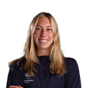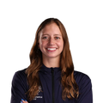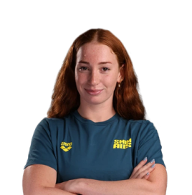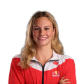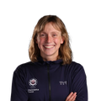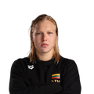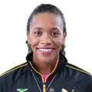
ΣΚΥΤΑΛΕΣ ΜΙΚΤΩΝ ΦΥΛΩΝ
ΑΓΩΝΙΣΜΑ | ΑΘΛΗΤΕΣ-ΑΘΛΗΤΡΙΕΣ | ΧΩΡΑ | ΗΜ/ΝΙΑ | ΕΠΙΔΟΣΗ | ΒΑΘΜΟΛΟΓΙΑ FINA
4Χ50 Ελεύθερο | GROUSSET M, MANAUDOU F, GASTALDELLO B, HENIQUE M | FRANCE | 16/12/22 | 1:27.33 | 1000
4Χ50 Μ.Ο. | MURPHY R, FINK N, DOUGLASS K, HUSKE T | UNITED STATES | 14/12/22 | 1:35.15 | 1000
4Χ100 Μ.Ο. | LIFINTSEV M, PRIGODA K, SURKOVA A, KLEPIKOVA D | RUSSIA | 14/12/24 | 3:30.47 | 1000

